# Setting Custom Spectrum Line Colors

There are various reasons that a user might want to specify custom line colors in the spectrum plot window. Some may simply not appreciate the current choice. Some may need to conform to publication guidelines. Others may find the current colors hard to differentiate.

Regardles of why, there is a mechanism for changing the colors used to draw the spectra in the main plot window.

TLDR: Add a CSV file named, “specColors.csv” to the “Base report path”. This ASCII file should contain 3 columns separated by commas containing values between 0 and 255 with the red, green and blue intensities.

## Instructions

1. Locate the “Base report path”. The location of the base report path is listed in the “HTML Report Location” section of the “User Information” tab in the “Preferences” dialog.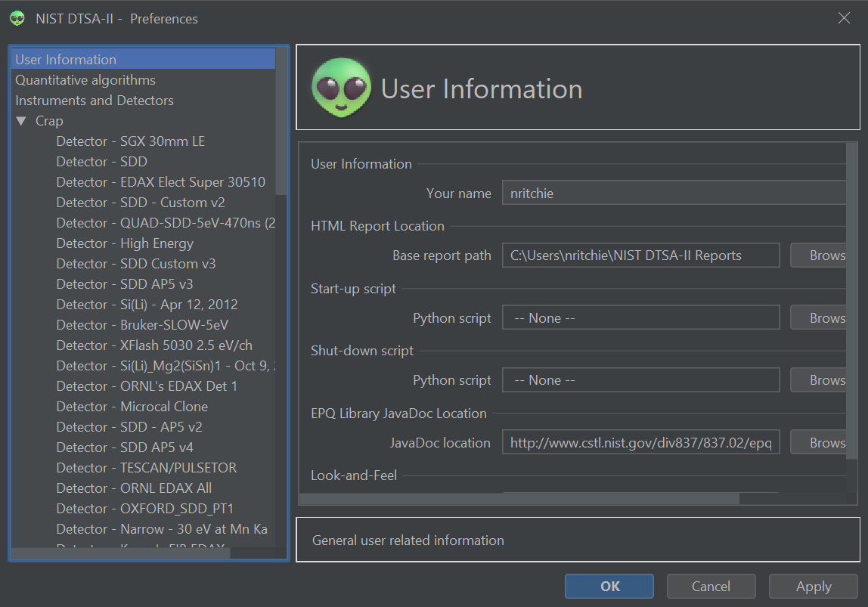
2. Using a text editor (notepad, NotePad++ or similar), create a text file called “specColors.csv” in the “Base report path” directory.
3. Enter colors, one-per-line, into the text file:  
   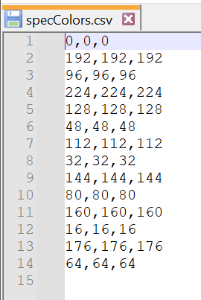  
   Each line consists of three different values (no spaces) representing the red hue, green hue, and blue hue. ‘0’ represents none of the hue, ‘255’ represents full intensity. Thus, red is ‘255,0,0’, green is ‘0,255,0’ and blue is ‘0,0,255’ and fuschia is ‘255,0,255’. In this example, the “colors” are gray-scale values because the red, green and blue values are equal. If there are more spectra than colors, the colors are recycled. You may find palette selection tools like <https://coolors.co/> helpful to make pleasing combinations of colors.
4. Save the file and restart DTSA-II.  
   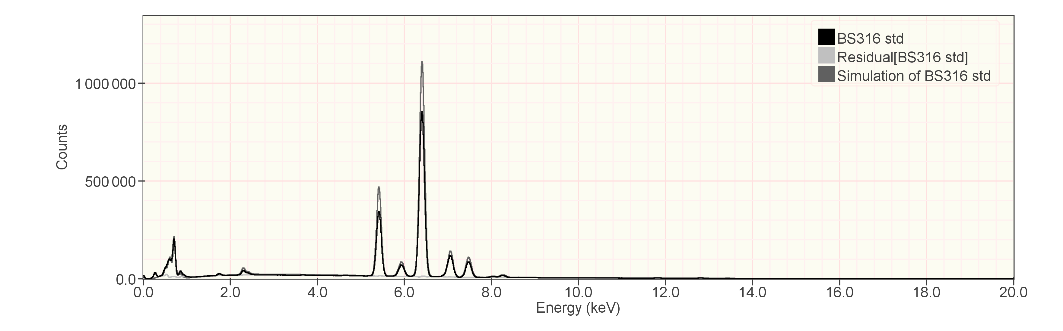  
   This example shows DTSA-II displaying spectra in grayscale.
5. Renaming “specColors.csv” will restore the default colors.

Nicholas W. M. Ritchie  
[nicholas.ritchie@nist.gov](mailto:nicholas.ritchie@nist.gov)  
11-Jun-2024